DEFINE THE PROBLEM STATEMENT

* A problem statement is a description of an issue to be addressed or a condition to be improved upon. It identifies the gap between the current problem and goal. The problem statement should be designed to address the Five WS. The first condition of [solving a problem](https://en.wikipedia.org/wiki/Problem_management) is understanding the problem, which can be done by way of a problem statement.
* Problem statements are used by most businesses and organizations to execute [process](https://en.wikipedia.org/wiki/Process_architecture) [improvement](https://en.wikipedia.org/wiki/Continual_improvement_process) projects.
* Broadly, a problem is an obstacle that exists between an intended objective and the current performance. A researchable problem therefore is problem over which data can be collected, organized and analysed.

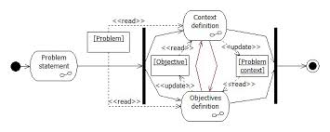

Purpose

* The main purpose of the problem statement is to identify and explain the problem. This includes describing the existing environment, where the problem occurs, and what impacts it has. Additionally, the problem statement is used to explain what the expected environment looks like.
* Another important function of the problem statement is to be used as a communication device. A problem statement helps with obtaining buy-in from those involved in the project. Before the project begins, the stakeholders verify the problem and goals are accurately described in the problem statement.
* The problem statement is referenced throughout the project to establish focus within the project team and verify they stay on track. At the end of the project, it is revisited to confirm the implemented solution indeed solves the problem. A well-defined problem statement can also aid in performing root-cause analysis to understand why the problem occurred and ensure measures can be taken to prevent it from happening in the future.
* It is important to note that the problem statement does *not* define the solution or methods of reaching the solution. The problem statement simply recognizes the gap between the problem and goal.

Defining the problem

* The process of defining the problem is often a group effort. It starts with meeting with the stakeholders, customers, and/or users affected by the issue (if possible) and learning about their pain points. Since people often struggle with effectively communicating their issues, particularly to someone outside of the process, it is helpful to ask a series of "why" questions until the underlying reasoning is identified. This method, known as the five whys, helps drill down to the core problem as many of the experienced frustrations could be mere symptoms of the actual problem. Asking these additional questions as well as paraphrasing what the stakeholder had said demonstrates a degree of empathy and understanding of the problem.

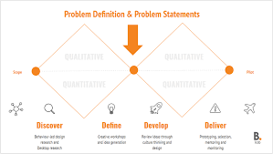

EMPATHIZE AND DISCOVER

* Empathy is the foundation of human-centered design. The problems you’re trying to solve are rarely your own, they’re those of particular users. Build empathy for your users by learning their values. To empathize, you:

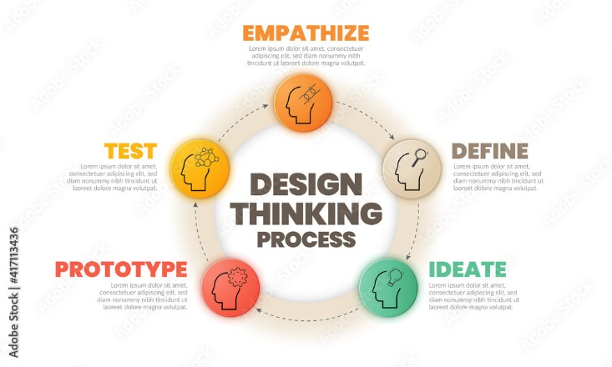

Observe

* Observehow users interact with their environment. Capture quotes, behaviours and other notes that reflect their experience. Watching users gives you clues as to what they think and feel – what they need.

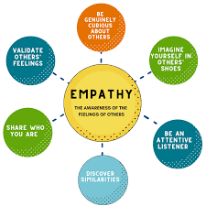

Engage

* Interact with and interview users through both scheduled and short ‘intercept’ encounters.
* Engage users directly—interact with and interview them. Engaging users reveals deeper insights into their beliefs and values.

Immerse

* Immerse yourself in your users’ experience. Find (or create if necessary) ways to immerse yourself in specific environments to understand first hand who you’re designing for.
* The best solutions come from the best insights into human behavior. Discover the emotions that drive user behavior. Uncover user needs (which they may or may not be aware of). Identify the right users to design for. Use your insights to design innovative solutions.

BRAIN STORM AND PRIORITIZE IDEAS.

* Here’s a general brainstorming definition: it’s an approach taken by an individual or team to solve a problem or generate new ideas for the improvement of a product, organization, or strategy.
* No matter your preferred method, most brainstorming techniques involve three steps:

1. Capture ideas
2. Choose which ideas to execute
3. Discuss and ideas critique the

* Every brainstorming technique also involves the same ingredients. All you need is an individual or group of people, a problem to solve or an opportunity to address, and time.

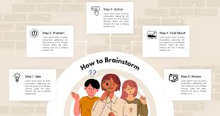

Brainstorming challenges

* The golden rule of all brainstorming sessions is quantity over quality. The more ideas you have, the better your chances are that one will be worthy of execution. For these reasons, especially in group brainstorming sessions, be sure all team members check their criticisms at the door and let it be known that the only bad ideas are no ideas.

* Of course, not every brainstorming session will go off without a hitch. Some common brainstorming challenges include:

1. Unbalanced conversations, sometimes due to extroverts dominating discussions
2. The anchoring effect, meaning brainstormers cling to the first few ideas shared and don’t move on to others
3. Awkward silences, which often occur when participants are not prepared

* Perhaps you’ve experienced some of these uncomfortable brainstorming sessions yourself. Thankfully, there are plenty of tried-and-true, and also some unorthodox, brainstorming techniques and tools that tackle just these issues.

